Continental Drift and Alfred Wegner
In 1915, Alfred Wegner proposed his Theory of Continental Drift. He proposed that the continents were once all joined together in a ‘supercontinent’ he called Pangaea. Over 180 million years ago this supercontinent began to "break up" due to continental drift. His evidence for the new theorywas
- The continents could be fit together (like a jigsaw puzzle).
- Worldwide distribution of fossils from the same time period.
- Rock layers in mountain chains on one continent match up with the rock layers in mountain chains on another continent.
- Rocks and fossils in many places don’t match the present climate or conditions.
During Wegner’s lifetime his theory was not widely believed. Wegner could not explain what would cause such huge sections of the earth to move so slowly and for so long. In addition, most people simply accepted that the world was stable – generally because they could not see any change in their lifetime.
Plate Tectonics
During the 20th Century, further evidence arose supporting Wegner’s theory.
- The use of sonar in WWII led to the discovery of underwater trenches and volcanic seams under oceans
- The magnetic record of the ocean floor is a mirror image on either side of seams.
- Satellites have been used to measure the spreading of the ocean floor.
This new evidence lead scientists developed the theory of Plate Tectonics. The theory suggested that the crust of the Earth is split up into seven large plates (see map below) and a few smaller ones, all of which are able to slowly move (less than 2.5 cm per year) around on the Earth's surface. They float on the semi-molten mantle rocks, and are moved around by convection currents within the very hot rock.
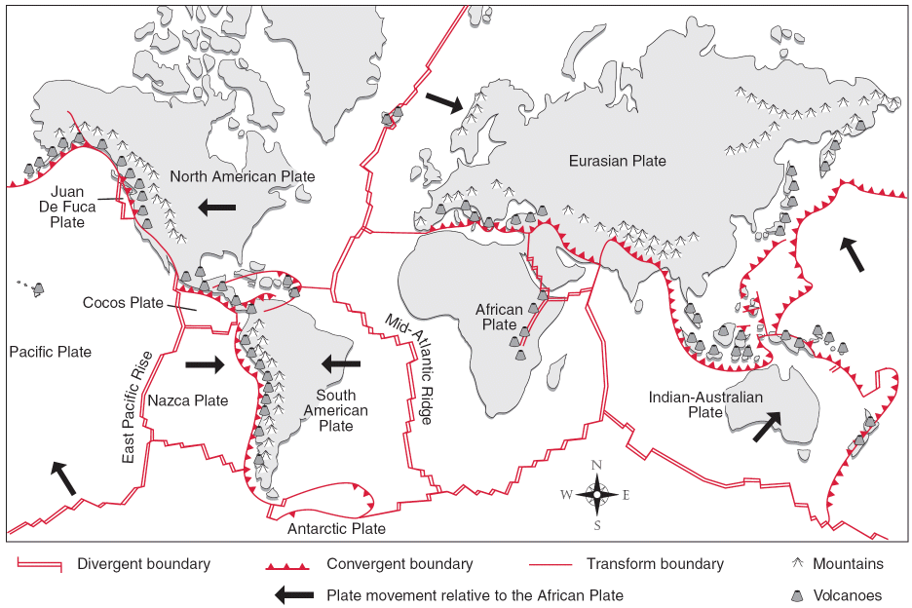
There are two types of tectonic plates - continental plates and oceanic plates. Continental plates contain continents and are lighter (less dense) than oceanic plates. Oceanic crust is much younger in geologic age than continental crust. Continental crust is on average thicker than oceanic crust.
Why do plates move?
The earth's tectonic plates are in constantly moving like giant 'rafts' on top of the semi-molten mantle below. However this movement is slow and rates vary from less than 2.5cm /yr to over 15cm/yr.
The movement of the earth's crustal plates is believed to be due to convection currents which occur in the semi-molten mantle. These convection currents are created by heat from within the earth - much of which is generated by radioactive decay in the core.
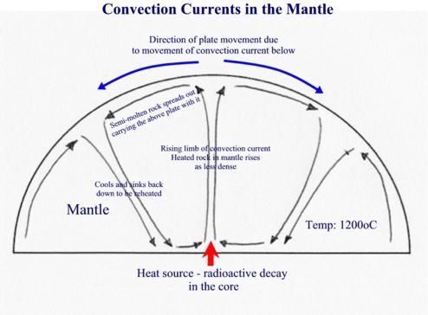
So how do convection currents cause plate movements? As semi-molten rock in the mantle is heated it becomes less dense than its surroundings and rises. As it reaches the crust above, it spreads out carrying the plates above with it. As the semi-molten rock then cools, it gradually sinks back down to be re-heated. (see diagram above)
Plate Boundaries
The point where two or more plates meet is known as a plate boundary. It is at these locations where earthquakes, volcanoes and fold mountain form. There are Three main types of plate boundary. These are Divergent, Convergent, and transform plate boundaries..
Plate Boundary | Diagram | Description | Landforms | Example
Divergent plate boundaries | 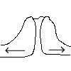 | Constructive plate boundaries occur when two plates move away from each other. | Ocean ridge and volcanic islands | North American and Eurasian Plate
Convergent Subduction plate boundaries  Oceanic vs Continental plates | 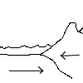 | Destructive plate boundaries occur when an oceanic plate is forced under (or subducts) a continental plate. | Fold Mountains and Oceanic trenches | Pacific Plate and the Eurasian Plate
Convergent Collision plate boundaries  Continental vs ContinentalPlates | 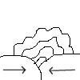 | Collision plate boundaries occur when two continental plates move towards each other. | Fold Mountains | Indo-Australian and the Eurasian Plate
Transform plate boundaries | 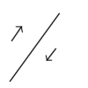 | Conservative plate boundaries occur when two plates slide past each other. | Fault and slip lines | North American Plate and the Pacific Plate
Hotspots
You should be aware that whilst most volcanoes / earthquakes occur along plate boundaries, there are exceptions. For example the volcanic Hawaiian islands which can be found in the middle of the Pacific Plate are formed due to a Hotspot. Hotspots are plumes of molten rock which rise underneath a thin or weak area in a plate causing localised melting and the creation of magma resulting in volcanic activity.

